# Prototype Description

We use android studio to create a system and we save the result {mind map , summarization ,word cloud } local in the device in any android devices ( tv , phone , tab ……. ) and use python to generate the mind map and make summarization and word cloud

Make a relation between android studio an muddle m5 in python let's get the result from our application

## Implementation Platform

Flask frame work

**Flask** is an API of **Python** that allows us to build up web-applications. It was developed by Armin Ronacher. **Flask's framework** is more explicit than Django's **framework** and is also easier to learn because it has less base code to implement a simple web-Application

Post man

Postman is a collaboration platform for API development. Postman's features simplify each step of building an API and streamline collaboration so you can create better APIs—faster.

Android studio by using java

You write Android apps in the Java programming language using an IDE called Android Studio. Based on JetBrains' IntelliJ IDEA software, Android Studio is an IDE designed specifically for Android development.

## Implementation Details

We are use many libariry for create mind map , word cloud and summarization :

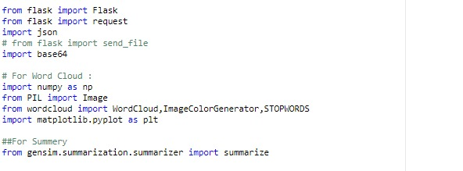

To implement summarization that sum up the text and make easier for user to read and under stand the text:

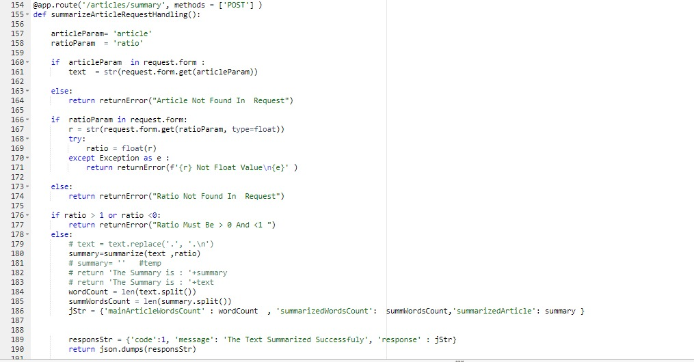

**to generate word cloud we use :**

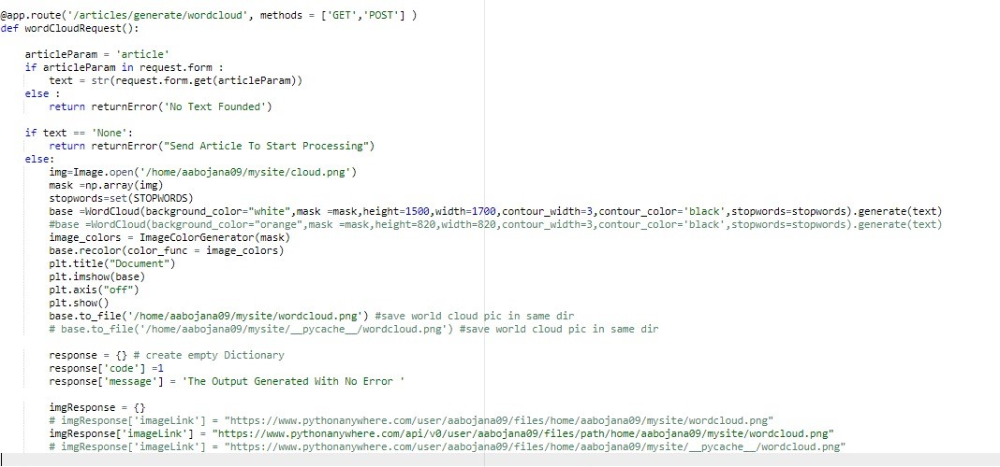

# Testing

[First to introduce the test/quality evaluation phase. What test tool you used for different testing? Then the detail will follow. This section is very important]